Module 5
Assignment 1: Short Answer Questions
1. What is an unordered list? Which tag is used for it?
An unordered list is a list of items without any specific order. The <ul> tag is used to create an unordered list.

2. What is an ordered list? Give one real-life example.
An ordered list is a list of items arranged in a specific order or sequence.
Example: Steps to prepare tea.

3. What is a description list?
A description list is used to display terms along with their descriptions. It uses the <dl> tag.

4. Write the difference between <ul> and <ol>.
<ul> displays list items with bullets.
<ol> displays list items with numbers or letters.

5. What is a nested list?
A nested list is a list inside another list.

6. Which tags are used to create a table in HTML?
The tags used are <table>, <tr>, <th>, and <td>.

7. What is the use of <th> tag?
The <th> tag is used to create table heading cells.

8. What is the difference between <th> and <td>?
<th> is used for table heading cells.
<td> is used for table data cells.

9. What is the purpose of the <caption> tag?
The <caption> tag is used to give a title or description to a table.

10. Where are HTML tables used in real websites?
HTML tables are used to display data such as student results, timetables, price lists, and reports.

Assignment 2: Fill in the Blanks
- The tag used to create an unordered list is <ul>.
- The tag used to create an ordered list is <ol>.
- List items are created using the <li> tag.
- The tag used to create a table row is <tr>.
- The tag used for table heading is <th>.
- The attribute used to merge rows is rowspan.
- The attribute used to merge columns is colspan.

Assignment 3: Match the Following
- <ul> — Creates an unordered list
- <ol> — Creates an ordered list
- <li> — Creates a list item
- <table> — Creates a table
- <tr> — Creates a table row
- <caption> — Adds a title to the table

🔹 Assignment 4: Practical – Lists
Create an HTML page that includes:
1. An unordered list showing at least 4 programming languages
2. An ordered list showing steps to create an HTML file
3. A description list explaining:
o HTML
o CSS
o JavaScrip
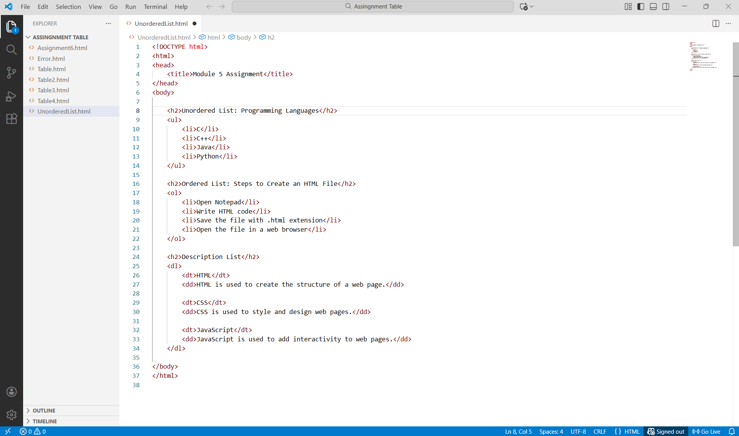

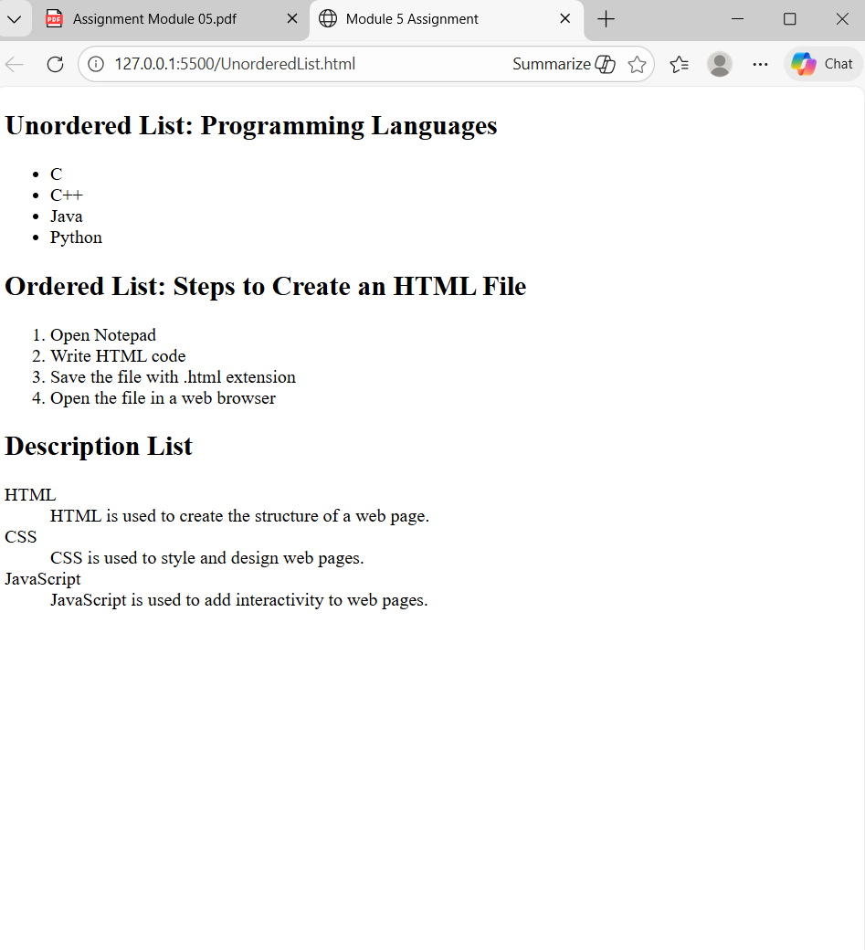
🔹 Assignment 5: Nested List (Practical)
Create a nested list for the following structure:
● Web Development o Frontend
● HTML
● CSS o Backend
● Node.js
● .NET
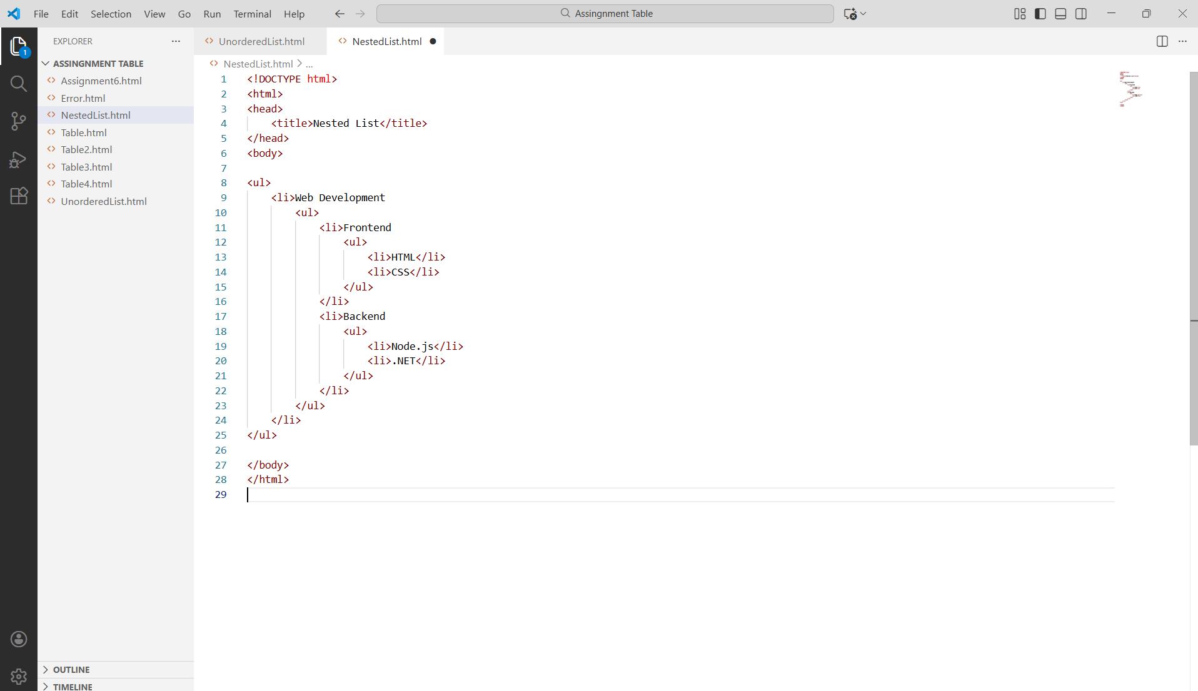
Output :
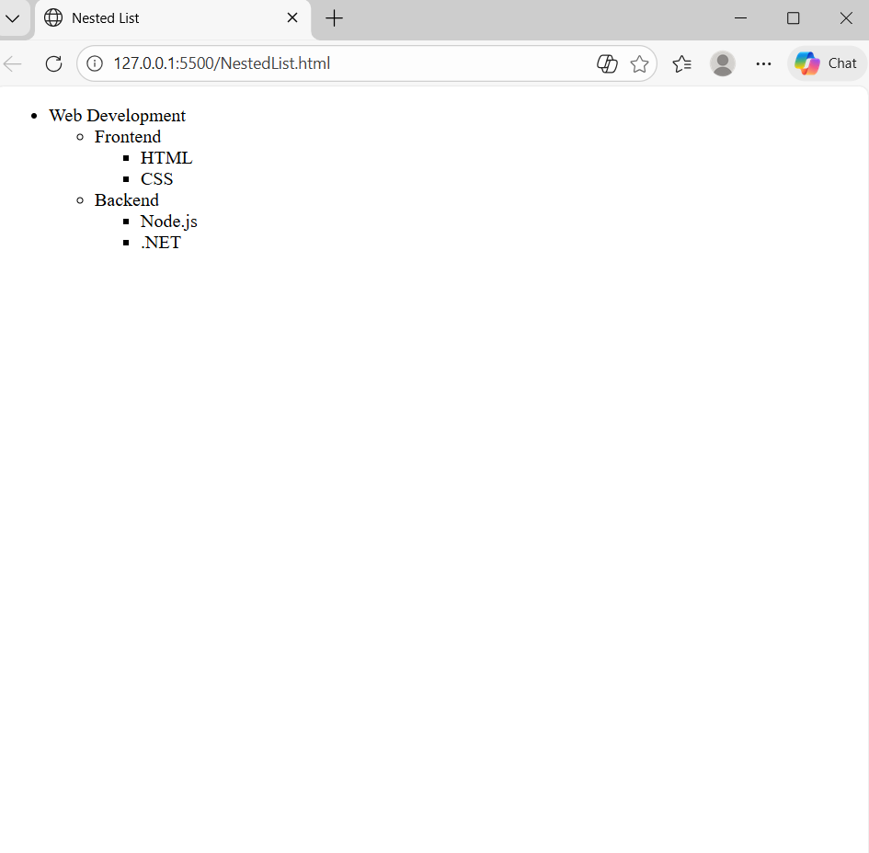
🔹 Assignment 6: Table Basics (Practical)
Create an HTML table with the following columns:
1. Roll No
2. Student Name
3. Course Add at least
3 rows of student data.
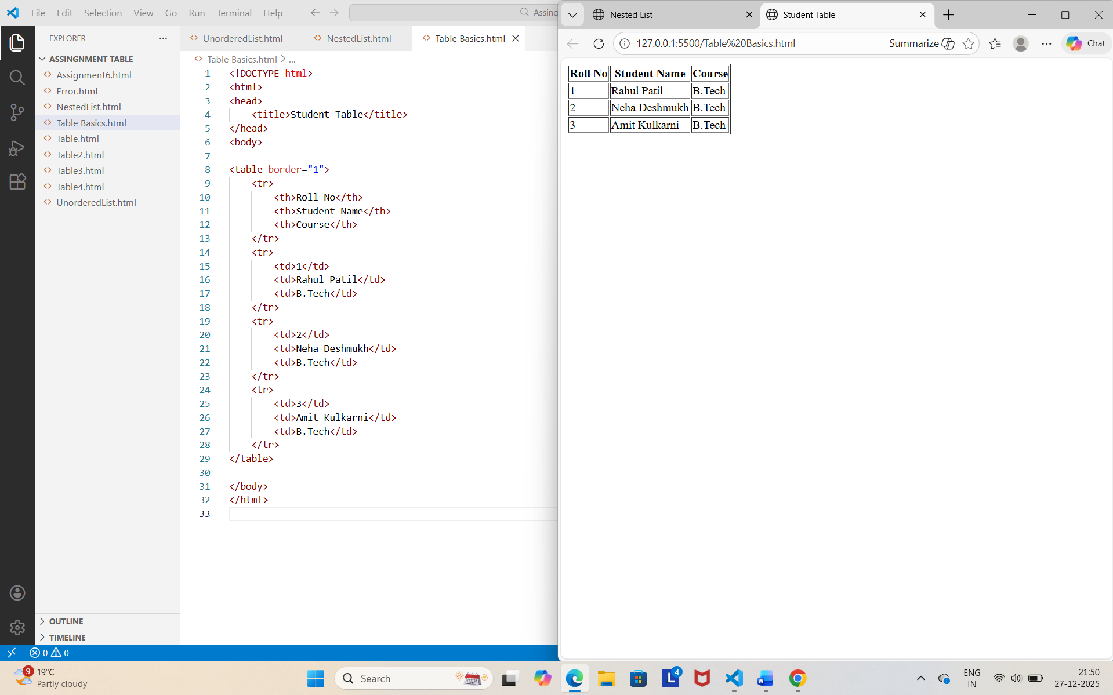

🔹 Assignment 7:
Table with Create a table showing Employee Details with a caption: Columns:
1. Employee ID
2. Name
3. Department
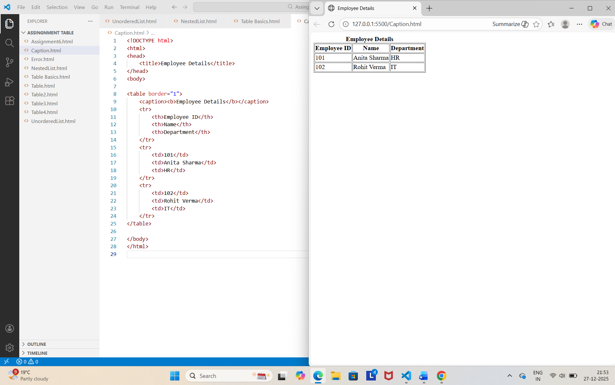

🔹 Assignment 8:
Rowspan & Colspan (Practical) Create a table for a college timetable that includes:
1. One cell using rowspan
2. One cell using colspan
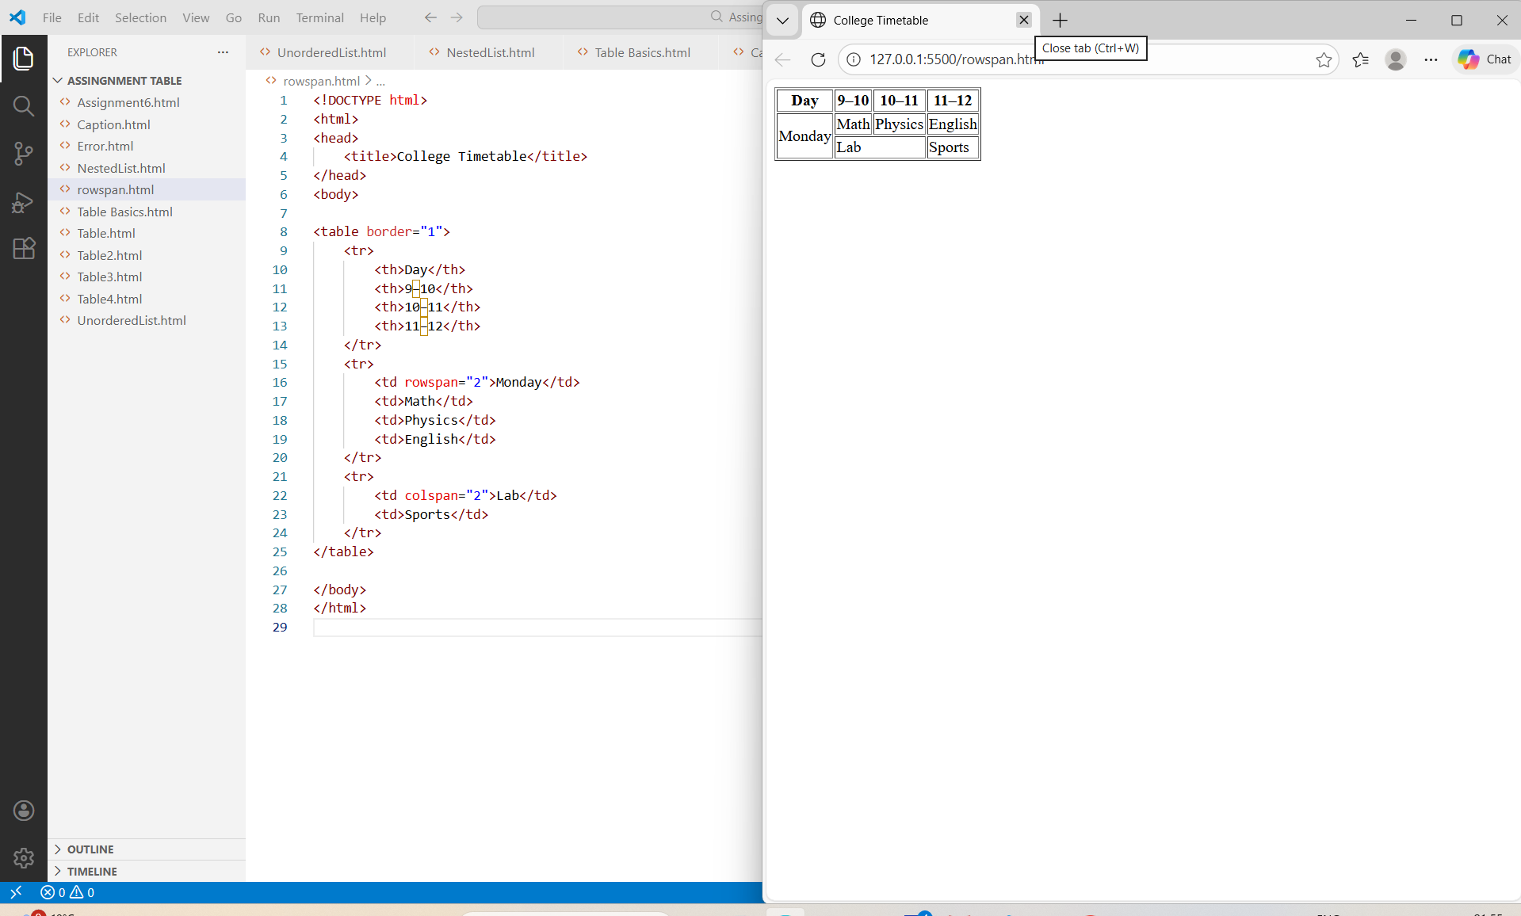

- Assingnment 9: Error Identification
Find and correct the errors in the following code:
<ul>
<p>HTML</p>
<p>CSS</p>
</ul>
<table>
<td>Name</td>
<td>Course</td>
</table>
Error 1: Incorrect content inside <ul>
<ul>
<p>HTML</p>
<p>CSS</p>
</ul>
Problem:
Inside a <ul> (unordered list),only <li> (list item) tags are allowed.<p>tags:
Here.
Correct Code:
<ul>
<li>HTML</li>
<li>CSS</li>
</ul>

Problem:
Inside a<ul> (unordered list),only<li> (list item) tags are allowed. <p> tags: here.
Correct code:
<ul>
<li> HTML</li>
<li>CSS</li>
</ul>

Error 2: Incorrect Structure of <table>
<table>
<td>Name</td>
<td> Course</td>
</table>

Problem:
<td> Tags must be inside a table row <tr>. A table Cannot have <td> directly inside:

Correct Code:
<table>
<tr>
<td>Name</td>
<td>Course</td>
</tr>
</table>

🔹 Assignment 10: Real-Life Scenario Questions
- Where would you use lists on a college or company website?
Lists are used to show items such as courses offered, departments, facilities, services, navigation menus, and announcements in an organized way.

- Where are tables commonly used on websites?
Tables are commonly used to display structured data such as timetables, student results, employee details, fee structures, and price lists.

- Why should tables not be used for page layout?
Tables should not be used for page layout because they make the design complex, are not responsive, and reduce website accessibility. CSS should be used for layout instead.

- Why are headings () important in tables?
Table headings () help users understand the meaning of each column or row. They also improve accessibility and make data easier to read.

